Resume of Mst. Hasina Khatun

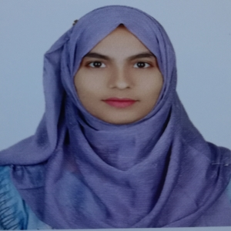

Parkmore, Rangpur.

Contact no.: +8801795265326

E-mail: stat1810065brur@gmai.com



***Educational Qualification:***

|  |  |  |  |  |  |
| --- | --- | --- | --- | --- | --- |
| **Sl** | **Degree**  **/ Exam** | **Subject**  **/ Major** | **Name of Institute** | **University / Board** | **Passing**  **Year** |
| 01 | MSc | Statistics | Begum Rokeya University, Rangpur | Begum Rokeya University, Rangpur | 2023 |
| 02 | BSc | Statistics | Begum Rokeya University, Rangpur | Begum Rokeya University, Rangpur | 2022 |
| 03 | HSC | Science | Nageswari Women College | Dinajpur | 2017 |
| 04 | SSC | Science | Kashipur M\L High School | Dinajpur | 2015 |



***Co-Curriculum Activities:***

* Make course profile and lesion plan for several courses.
* Work for Sport committee and Picnic arrangement committee.



***Computer Skills:***



* Bootstrap, Matlab, Phython, C, C++, C#, Java, Java Script, PHP, MySQL, Oracle

Personal Details

Name: Mst. Hasina Khatun

Father: Md Aminul Islam

Mother: Mst. Surotan Begum

Birth Date: 07 May, 1999

Permanent Address:

Village: Moddha Kashipur, Post: Gongerhat

Thana: Phulbari, District: Kurigram,

Post Code: 5680



***Date: 10.01.2025 Mst. Hasina Khatun***